# INTRODUCTION

* 1. Overview
* Agriculture is the backbone of Indian economy. Agriculture is the most important occupation for most of the Indian families.
* In India, agriculture contributes about 16% of total GDP and 10% of total exports.
* That’s reason India secured second position Worldwide in terms of farm output. About 75% people are living in rural areas and are still depended on agriculture. About 43% of India’s geographical area is used for agricultural activity.
* Indian agriculture began by 9000 BCE as a result of cultivation of plants, and domestication of crop and animals. Settled life soon followed with implements and techniques being developed for agriculture.
  1. Purpose
* Agriculture, with its allied sectors, is unquestionably the largest livelihood provider in India, more so in the vast rural areas. It also contributes a significant figure to the Gross Domestic Product (GDP).
* Crop production is one of the fundamental branches of agriculture. Crop production is the basis for providing the livestock industry with feed, and the population with food.
* Agriculture impacts society in many ways,

Including: Supporting livelihoods through food, habitat, and jobs; Providing raw materials for food and other products; And building strong economies through trade.

* Agriculture is the most significant source of income for the central and state government.

1. **Problem Definition & Design Thinking**
   1. Empathy Map

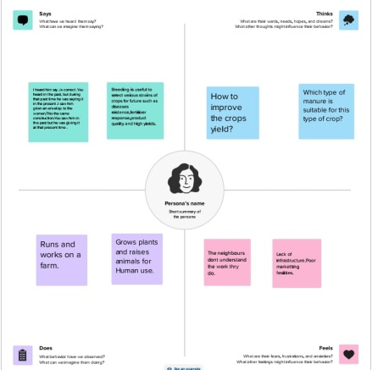

* 1. Ideation & Brainstorming Map

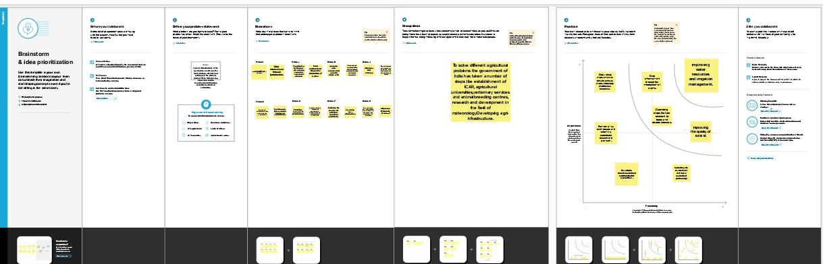

# RESULT

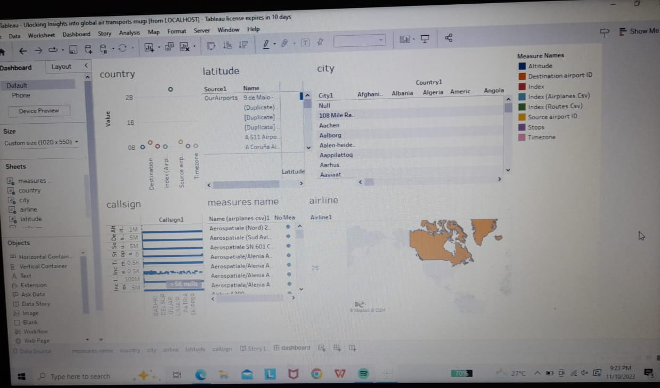

# ADVANTAGES & DISADVANTAGES

**ADVANTAGES:**

* Agriculture supplies raw materials to various agro-based industries like sugar, jute & cotton textiles. Food processing industries are similarly depended on agriculture.
* A well planned production function will lead to good quality products, higher rate of production and lower cost per unit. The consumers will be benefitted from prices of goods and will get good quality products.
* It is the main stay of Indian economy because about 60% of our people depend directly or indirectly on agriculture.

**DISADVANTAGES:**

* Erosion of soil by heavy rain, floods, insufficient vegetation cover etc., Reduces farm productivity.
* Inadequate irrigation facilities and poor management of water resources have led to a great declined in agricultural productivity.
* IMPACT ON NATURAL HABITATS: The necessity of seeking new territories for industrial agriculture needs affects wildlife and deprives it of traditional living places.
* HUMAN HEALTH IMPACT: Extreme chemical quantities in consumed plants induce issues in the human body, including even congenital abnormalities.

# APPLICATIONS

* The most common soil application used mainly for open field crops is fertilizer broadcast. It is a method by which the fertilizers are applied on the surface across an entire field.
* Often high capacity spreaders are used to spin dry fertilizer on the soil surface.
* Ability to collect real-time data on the variables occurring in the crop fields. Reduction in the use of inputs and labor, thus reducing costs.
* Besides, these earlier we use to depend completely on monsoon for the cultivation of food grains but now we have constructed dams, canals, tube-wells & pump-sets.
* Also, we now have a better variety of fertilizers, pesticides and seeds, which help us to grow more food in comparison to what we produce old times.

# CONCLUSION

The Indian economy is an agro-economy and depends highly on the agricultural sector. Despite just supporting the Indian economy, the agricultural sector also supports the industrial sector and international trade in imports and exports. The agricultural sector is vital importance for the region. It is undergoing a process of transition to a market economy, with substantial changes in the social, legal, structural, productive and supply set-ups, as is the case with all other sectors of the economy.

# FUTURE SCOPE

* India’s agriculture sector plays a critical role in the country’s bio-ethanol sector, as well as supporting moves toward food security, energy security and de-carbonization goals. The country has come a long way with bio-ethanol policies, and it is likely to achieve a 10% ethanol blending target in 2023-24.
* There will be more of vertical and urban farming and there will also be efforts in long term to find new areas for production like barren deserts and sea water.
* Agriculture encompasses crop and livestock production, aquaculture, fisheries and forestry for food and non-food products.

# APPENDIX

 <https://public.tableau.com/app/profile/prabhavathi.p8820/viz/URCW-Team4agriculturalcrop/Story1?publish=yes>

<https://public.tableau.com/app/profile/prabhavathi.p8820/viz/URCW-Team4agriculturalcrop/Dashboard1?publish=yes>

<https://public.tableau.com/app/profile/prabhavathi.p8820/viz/URCW-Team4agriculturalcrop/Dashboard2?publish=yes>

<https://public.tableau.com/app/profile/prabhavathi.p8820/viz/URCW-Team4agriculturalcrop/Dashboard3?publish=yes>